Swiggy Sales Analysis Report
Name: Sparsh sharma
Date: 3 April 2026

1. Business Problem Statement
The objective of this project is to analyze food delivery data to understand sales performance, customer behavior, and restaurant trends. The goal is to identify key insights that can help improve revenue, customer satisfaction, and business growth.

2. Data Overview
The dataset includes order-level details such as location, order information, product categories, pricing, and customer ratings. Data cleaning and transformation were performed using Power BI Power Query to ensure accuracy and consistency.

3. Key Performance Indicators (KPIs)
- Total Sales: ₹53.01M
- Total Orders: 197K
- Average Order Value: ₹268.51
- Average Rating: 4.34
- Zero Rating Orders: 79K

4. Dashboard Overview
A Power BI dashboard was created to visualize:
- Sales trends over time
- City-wise performance
- Category-wise sales
- Customer rating distribution
- Geographic sales distribution
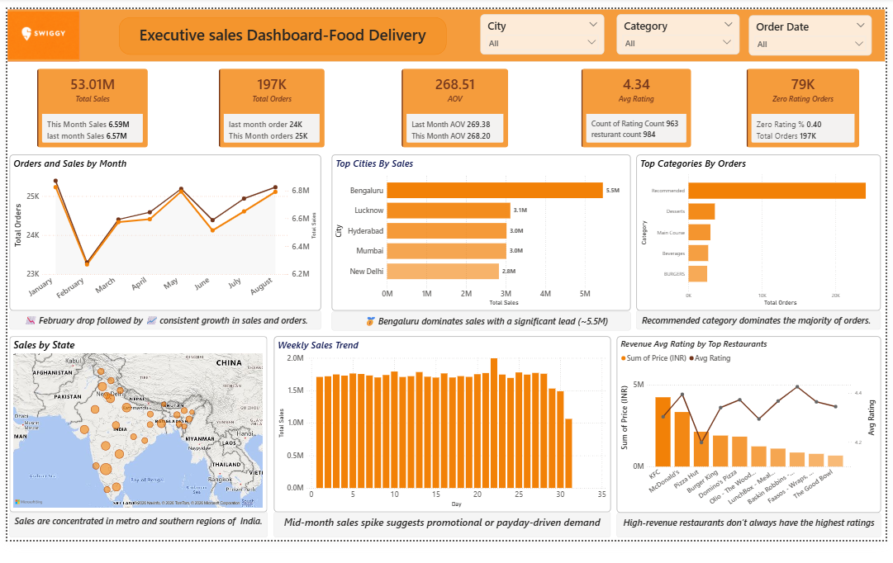
5. Key Insights
- Bengaluru is the highest revenue-generating city
- Sales show a noticeable decline in February
- Recommended category contributes the most orders
- Sales peak during mid-month periods
- High number of zero-rating orders indicates low engagement
- High revenue does not always mean high customer satisfaction

6. Recommendations
- Expand operations in low-performing regions
- Improve customer engagement to increase ratings
- Promote high-rated but low-selling items
- Run targeted campaigns during low-sales periods
- Improve service quality for high-revenue restaurants

7. Conclusion
This analysis highlights important trends in sales and customer behavior. The insights derived can help the business optimize its strategy, improve customer satisfaction, and drive sustainable growth.

